Chapter 9
Act of Terrorism

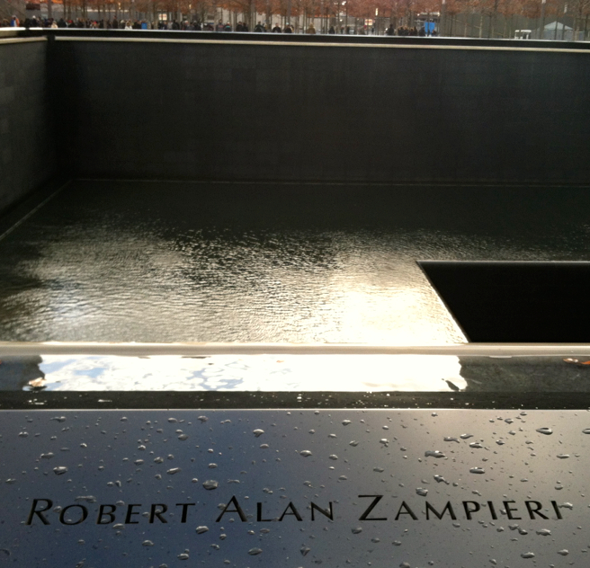
“Contrary to the ideas April Brown is trying to propose, Ms. Ellis has never taken money from a grieving family...” March 2012 Linda Ellis
The Zampieri family is the kind of family we all wish we had been born into. Brilliant, loving, fun, generous, and kind are all words that come to mind when I think of the patriarch Robert Zampieri and his wife, Patricia. Their son Michael followed in his father’s footsteps and is highly a regarded dentist. Daughter Jeannie also entered the dental field, and became her father’s office manager and dental assistant. Their brother, Robbie, was a commodities trader at Carr Futures when on Tuesday, September 11th, he became one of the nearly 3,000 people murdered in the terrorist attack on the World Trade Center. On what was to be Robbie’s 31st birthday, his body was found in the twisted metal and debris.
The family responded to Robbie’s death by staying connected with the people they love and those who love them. They established The Robbie Zampieri Scholarship Fund to financially assist families who want their children to receive an education from St. Anthony’s in North New Jersey. The fund has raised more than a million dollars to date. Robbie’s spirit is with his family every minute of every day, and his legacy will live on because of this scholarship fund.
Jeannie’s father-in-law, Joseph Schlesinger, died exactly 11 years to the day of the terrorist attack, on September 11, 2012. Joe, too, was a kind and loving man. And like Robbie he said few words and was treasured by all who met him. Even though Joe was Jeannie’s father-in-law, the Schlesingers loved Robbie like a firstborn son. One of their favorite places to gather was at the Schlesingers’ beach house for spectacular dinners and play.

Like the Zampieris, the loss of Robbie tore through the hearts of the Schlesinger clan. But losing two loved ones on September 11th, years apart, was even harder to digest. Both families felt consoled knowing that Robbie was waiting for Joe with open arms on the other side. When it was time to plan Joe’s funeral, his wife mentioned she had heard a beautiful poem that was read at a friend’s funeral and she wanted it to be read during Joe’s service. The family planned the service and The Dash was read aloud before grief stricken family, friends, and colleagues. Jeannie decided to share the poem in the Zampieri Dental Care Newsletter. In a few short months, the newsletter came into the crosshairs of John W. Jolin, and a string of unsolicited letters demanding money began rolling in.

The timing of The Dash extortion letter could not have been worse. Not only had the family just relived the death of a beloved brother and buried Jeannie’s father-in-law, her father discovered his rare cancer had returned. That same October, Hurricane Sandy wiped out the Zampieri family vacation home and burned her mother-in-law’s and brother-in-law’s vacation homes to the ground. And if all this wasn’t enough to grapple with, within days of receiving Jolin and Linda Ellis’s extortion letter, her mother fell on a patch of ice and broke her wrist. The injury sidelined Mrs. Schlesinger and kept her from tending to her ailing husband for more than two months.
The demand letter just added more duress to the challenges and changes the Zampieri family had been forced to live through. Jeannie thought, “Really? You want me to pay you money for sharing a poem in a newsletter?” Jeannie called the phone number in Jolin’s letter. To her surprise it was out of service. Convinced Jolin’s letter was a scam, she searched the Internet and found my BEWARE DON’T SHARE blog and placed a call to me. When I heard her story, I was furious, but Jeannie presented the list of tragedies with little emotion. It was if she was resigned to more tragedy. Her composure was astonishing considering the natural and man-made disasters that had befallen this family — death, storms, fire, disease, and injury. Here was another family victimized by Ellis because a loved one died. I reassured Jeannie and let her know the letter was a lie. I told her she shouldn’t fear being sued and she should not pay off Linda Ellis. I reminded her that Linda Ellis has never been granted monetary damages in any court and certainly not the Federal Court against someone who posted The Dash on a blog or in a newsletter. I explained the Aronson case that Jolin cites in his letter. I told her the stories of other targets and victims who had never heard of Linda Ellis until they shared The Dash as Author Unknown. I asked Jeannie if I could share her story on my blog and in this book, and she immediately said yes.
The family has much to be angry and bitter about, but in the words of the family’s patriarch, “The Zampieri family only wants love.” Linda Ellis and John Jolin only want the Zampieri family’s money. Linda Ellis has been digging up bones for profit for many years. Sometimes she finds the bodies that sparked the desire to share The Dash within days of their demise. Sometimes it takes her years. But according to Linda Ellis, she has made a fortune chasing hearses and robbing graves. Her letters arrive in homes and businesses at times of already established crisis and inconsolable grief. One letter arrived the day after a family held a memorial for the director of their organization. Another arrived the day a family’s home was lost to foreclosure. I talked with one small-business owner who told me her partnership broke up because of Linda Ellis’s scheme. I know of one church that had to hold a fundraiser to pay her off.
Linda recently posted that because the Zampieri Family owns a business that their unauthorized use of the poem justified her demands while at the same time she denies she sent them an extortion letter. This is an excerpt from her letter to the family. “…Unauthorized publications of The Dash in connection Zampieri Dental Care, including its publication on http://www.zampieridental.com/razviewpointfall2012 (the “Website”) constitutes federal copyright and trademark infringement…Based on your unauthorized use and contributing to the perpetual unlawful distribution of registered copyrighted work of the Poem, we ask that you pay $7,500.00 to resolve our claims of trademark and copyright infringement.”
She wants people to believe I make these stories up but the Zampieri family bears witness to her scheme. The Zampieri family is real and Robbie really died and so did his father Joe and Linda Ellis really tried to extort $7500 from the Zampieris.
“…..My company does not take money from 9-11 families or grieving mothers or anyone like that...never has. If you have proof of this, I need to see it. I PROMISE you it's never happened under my watch, with my knowledge, with my blessing or by anyone employed by me.” Posted by Linda Ellis on my Facebook page January 2015.

$

